PBL PROJECT

On

**AUTOMATIC MAIL SENDER WITH VOICE DETECTION**

*Submitted to JNTU HYDERABAD*

*In Partial Fulfillment of the requirements for the Award of Degree of*

**BACHELOR OF TECHNOLOGY**

**IN**

## COMPUTER SCIENCE AND ENGINEERING

Submitted By

**Nayaki Srihari (208R1A0591)**

Under the Esteemed guidance of

### Mrs. Amitha Mishra

Assistant Professor, Department of CSE



**Department of Computer Science & Engineering**

# CMR ENGINEERING COLLEGE

(*Accredited by NBA,* Approved by AICTE, NEW DELHI, Affiliated to JNTU, Hyderabad) Kandlakoya, Medchal Road, R.R. Dist. Hyderabad-501 401)

**2021-2022**

# CMR ENGINEERING COLLEGE

*(Accredited by NBA, Approved by AICTE, NEW DELHI, Affiliated to JNTU, Hyderabad) Kandlakoya, Medchal Road, R.R Dist, Hyderabad-501 401)*

**Department of Computer Science & Engineering**



## CERTIFICATE

This is to certify that the project entitled **“AUTOMATIC MAIL SENDER WITH VOICE DETECTION”**is a bonafide work carried out by

**Nayaki Srihari (208R1A0591)**

in partial fulfillment of the requirement for the award of the degree of **BACHELOR OF TECHNOLOGY** in **COMPUTER SCIENCE AND ENGINEERING** from CMR Engineering

College, affiliated to JNTU, Hyderabad, under our guidance and supervision.

The results presented in this project have been verified and are found to be satisfactory. The results embodied in this project have not been submitted to any other university for the award of any other degree or diploma.

|  |  |  |
| --- | --- | --- |
| Internal Guide |  | Head of the Department |
| **Mrs. P.Amitha Mishra** |  | **Dr. Sheo Kumar** |

|  |  |  |
| --- | --- | --- |
| Assistant Professor |  | Professor & H.O.D |
| Department of CSE  CMREC, Hyderabad |  | Department of CSE   |  |  |  | | --- | --- | --- | | CMREC, Hyderabad | CMREC, Hyderabad | CMREC, Hyderabad | |

## DECLARATION

This is to certify that the work reported in the present project entitled **“ AUTOMATIC MAIL SENDER WITH VOICE DETECTION ”** is a record of bonafide work done by us in the Department of Computer Science and Engineering, CMR Engineering College, JNTU Hyderabad. The reports are based on the project work done entirely by us and not copied from any other source. We submit our project for further development by any interested students who share similar interests to improve the project in the future.

The results embodied in this project report have not been submitted to any other University or Institute for the award of any degree or diploma to the best of our knowledge and belief.

**Nayaki Srihari (208R1A0591)**

### ACKNOWLEDGMENT

We are extremely grateful to **Dr. A. Srinivasula Reddy**, Principal and **Dr. Sheo Kumar**,

HOD, **Department of CSE, CMR Engineering College** for their constant support**.**

We are extremely thankful to **Mrs. Amitha Mishra,** Assistant Professor, Internal Guide, Department of CSE, for her constant guidance, encouragement and moral support throughout the project.

We will be failing in duty if I do not acknowledge with grateful thanks to the authors of the references and other literatures referred in this Project.

We express my thanks to all staff members and friends for all the help and co-ordination extended in bringing out this project successfully in time.

Finally, we are very much thankful to my parents who guided me for every step.

**Nayaki Srihari (208R1A0591)**

## CONTENTS

### TOPIC

#### ABSTRACT

#### INTRODUCTION

* 1. Introduction & Objectives
  2. Purpose of the project
  3. Existing system & Disadvantages
  4. Proposed system with Features

#### SOFTWARE REQUIREMENT ANALYSIS

* 1. Problem Specification
  2. Modules and their Functionalities
  3. Requirements
  4. Feasibility Study

1. **SOFTWARE & HARDWARE REQUIREMENTS**

3.1 Software requirements

3.2 Hardware requirements

#### SOFTWARE DESIGN

* 1. System Design Phases of The Proposed System
  2. Implementation
  3. Flow chart
  4. Use Case diagram
  5. Class diagram

#### CODING

* 1. Sample code 29

|  |  |
| --- | --- |
| **6. OUTPUT SCREENS** |  |
| **7. CONCLUSION** |  |
| **8. FUTURE SCOPE AND ADVANTAGES** |  |
| **9. REFERENCES** |  |

#### 

#### ABSTRACT

The main idea of our project is to automate the sending of mails by voice recognition without the need of typing anything including the receiver mail id , subject and text inside the mail.

The whole process of sending a mail can be done just through voice commands without the requirement of typing anything on keyboard**.** To develop a voice primarily based email system that will facilitate individuals to access email in a problem free manner. Together with providing usage of mail services simply and with efficiency, the system also will cut back the psychological feature work that must be unremarkably taken by the visually impaired to recollect and sort characters using the normal Braille keyboards, which are accessible to them. This application provides a voice primarily based mailing service which provides them to browse and send mail on their own, without any guidance. This EMAIL system is utilized by a visually handicapped person to access mails easily and with efficiency.

1. **INTRODUCTION**
   1. **INTRODUCTION & OBJECTIVES**

A voice mail system is a computer-based system that allows users and subscribers to exchange messages without typing. emails are very important for communication as each professional communication can be done by emails and the best service for sending and receiving mails is as we all know GMAIL. Gmail is a free email service developed by Google. Users can access Gmail on the web and using third-party programs that synchronize email content through IMAP protocols.

Normal Gmail does not contain the voice recording option. In this project we are designing a record option and the recorded voice is converted to text and sent to the particular mail. Now a days many people are very busy, so they are interested in recording a message and sending it instead of typing it.

A voice mail system is a computer-based system that allows users These systems are designed to convert a caller's recorded audio message in to text and then it will be sent to a recipient. for blind people, as every official messages are only sent through mail they cannot text the message so our application helps them a This system acts as an application which contains accessible user Normal Gmail does not contain the voice recording option. project we are designing a record option and the recorded voice is converted to text and sent to the particular mail. people are very busy, so they are interested in recording a message This type of application helps people in a way of time consuming like it asks the user to enter the message and the entered message mail id and then it sends when we say to send the message. The voice Activation Detection API is used to convert our audio The application consists of user interface that has a two text boxes, one is used for entering the message and the other is used for entering the recipient mail id. authenticator, which efficiently performs its task of providing Communication is very difficult task for blind people or visually As visually impaired people cannot able to read or text back a response to the message**.**

* 1. **PURPOSE OF THE PROJECT**

project we are designing a record option and the recorded voice is The main idea of our project is to automatically send the emails with help of voice recognition without the need of typing anything. This idea is helpful to people who are visually challenged and also to people who are physically handicapped. E-mails are considered to be the most reliable way of communication over Internet, for sending or receiving some important information. Yes, there are some visually challenged people or blind people who cannot see things and thus cannot see the computer screen or keyboard. ->Our project aims to provide a better user experience to the visually challenged people. With the help of our project just by passing some voice commands we can be able to send the mails Without the need of typing anything on the keyboard A survey shows that there are more than 250 million visually challenged people around the globe. That is, around 250 million people are unaware of how to use Internet or E-mail. Earlier, blind people do not send email using the system. all types of people such as blind people they can’t send the email. Audio based email are only preferable for blind peoples. the blind people. This application can be used by both normal people and physically impaired. It also reduces human effort and save time by automating the sending of mails through voice recognition. The main benefit of this system is that the use of keyboard is completely eliminated, the user will have to respond through voice only.

* 1. **EXISTING SYSTEM & DISADVANTAGES**

There are a large number of email users. The email systems that we typically use the user can hear out the content of the There are many screen readers available in readers read out the content present on the screen and guide the user to perform certain actions to achieve respective to perform these actions, the user needs to use keyboard shortcuts and ultimately for that, the user needs to know cannot be traced by the screen readers as well as the user, these systems are not. Use of screen readers makes it difficult for blind person to access E-mail system as screen readers cannot trace the location of mouse Existing systems require basic information systems are not of very much use for blind for the blind users are still unavailable for mobile phone application that could understand and read out the information by the camera, the user will be prompted through speech output to bring the camera provided to the user through voice output. The drawback in systems using screen readers is that the screen readers read the only understand the content written in Therefore, the user will be able to know the contents of the screen Thus, screen readers are unable to Existing Systems. Existing Systems do not provide easy access to the visually challenged people because screen readers that enable these people to access the desktop applications, we do not help these people to access the web mail service fails in providing the user using these types of systems. The visually challenged cannot use voice-based applications. request in form of text from user and retrieve the relevant form of text which is not possible for visually challenged Although the existing web browsers can play audios and videos, but for that also the user has to request by typing some text to search after that the user will be able to play the audio The existing email system do not provide this facility and are not accessible by blind people.

* 1. **PROPOSED SYSTEM WITH FEATURES**

The proposed system will make the email system very easily accessible to visually challenged people and also help society. Authors proposed the system keeping one idea in mind that it should be easily accessible for all kind of persons. Any designed web application is claimed to be excellently accessible, if it is used by any person, visually challenged or not with efficient manner. As critical the present system that prioritizes user-friendliness of traditional users, proposed system focuses on user-friendliness of all kinds of individuals, together with traditional folks and visually weakened folks additionally as illiterate people. In this system, the pc is going to be prompting the user to perform specific operations to avail various services and if the user has to access the various services, then he/she has to perform that operation. Firstly, the user will have to register in application system through the registration form. The user goes to be assisted through voice commands whereas registering all the mandatory fields to be stuffed are going to be scanned by website; once the user would speak it would get written automatically. After successfully registering, the user can log in by speaking the Username and Password when prompted by the system, this username and password will then be converted from speech to text and then the user will be authenticated by verifying the credentials with the database. Users can access various sections like Compose, Inbox, and Sent Mail after successful login.

1. **SOFTWARE REQUIREMENT ANALYSIS**
   1. **PROBLEM SPECIFICATION**

One of the most essential privileges for daily life is access to the internet. Everyone uses the internet for facts and information. Communication has gotten much easier in today's society as a result of the integration of communication technologies with the internet. Visually impaired persons, on the other hand, find it extremely difficult to use this technology because it requires visual perception. Despite the fact that many new advancements have been implemented to assist them in using computers more effectively, no naive user who is visually challenged can use this technology as effectively as a normal naive user because, unlike normal users, they require some practice in using the available technologies. This study discusses the structural design of a voice-mail system that may be utilized by a blind person to readily retrieve E-mails. This strategy allows them to communicate easily and generates a lot of stronger and independent workers. The system will not allow the user to utilize the keyboard or keypad, instead relying solely on clicks, swipes, and motions, as well as speech to text conversion. The involvement of research is assisting blind people in sending and receiving voice-based mail messages in their native language via a mobile phone.

There is a special criterion for humans to access the Internet and the criterion is you must be

able to see. But there are some visually challenged people or blind people who cannot see things and thus cannot get the benefit of technology. So, for the betterment of society and giving an equal status to such especially abled people we have come up with this project idea.

* 1. **MODULES AND THEIR FUNCTIONALITIES**

The modules are:

1. Applock.

2. Sign up/Registration.

3. Sign in/Login.

4. A Textbox used for sender mail id.

5. A Textbox used for recipient mail id.

6. Database design

7.System design

1. **APPLOCK**: As there should be privacy for the application applock should be maintained compulsory. But the app lock available in each mobile by default, so they can use it.

2. **SIGNUP/REGISTRATION**: First the users who are going to use this application should be register with their valid email id, password and they should keep a 5digit numerical code as password.

3. **SIGNIN/LOGIN**: When the user opens the application then it will ask the registered mail id and numerical password only. As it is mainly for blind people or visually impaired, we will be maintaining a numerical password.

4. **A TEXT BOX USED FOR SENDER MAIL ID:** The system asks the user to enter the sender email id. As it has voice recognition application programming interface, which automatically enters the mail id in the particular textbox whenever the user speaks or reads it.

5. **A TEXT BOX USED FOR RECIPIENT MAIL ID:** The system asks the user to enter the recipients mail id. In the same way when the user speaks, it automatically enters the mail id. 6. SUBJECT BOX: A subject or message box is available in which the user can enter the message what they want to send or convey to the recipient.

6. **DATABASE DESIGN**: Database is important in every project since it is responsible for storing of data and user credentials. That is, database mainly aims User authentication and storing all the user mails. The database design will include various tables’ creation for storing emails.

7. **SYSTEM DESIGN**: The system will consist all the modules such as: TTS (Text to Speech) and STT (Speech to Text) module, Mail programming module (Compose, Inbox, and Sent Mail).

**2.3 REQUIREMENTS:**

The input/output in this software is in the form of forms, speech, and gestures. The data is saved in tables in a database, which is where the storage process takes place. The computation is done via queries, APIs, and procedures that are designed to take as little time as possible. The user will initially register with the system so that he or she can log in later, similar to how a naive person would do with an existing gmail account. After successfully registering and logging in, the user will be sent to the main menu, which includes operations like as compose, inbox, and trash. After selecting a specific operation, the user will finish the operation by performing the related activities. Finally, the API will conduct tasks by connecting to Google's email account. The data flow diagram depicts the flow of a set of data in accordance with a specific information system paradigm. It's used to sketch out a data system's design and structure without providing processing time alternatives in order, such as yes or no choices in traditional flow chat time.

* Python(3 or greater)
* A Gmail Account
* Google API Client
* pyttsx3 module
* speech_recognition module
  1. **FEASIBILITY STUDY**

Python comes with the built-in smtplib module for sending emails using the Simple Mail Transfer Protocol (SMTP). smtplib uses the RFC 821 protocol for SMTP. The examples in this tutorial will use the Gmail SMTP server to send emails, but the same principles apply to other email services

Python, being a powerful language don’t need any external library to import and offers a native library to send emails- “SMTP lib”. “smtplib” creates a Simple Mail Transfer Protocol client session object which is used to send emails to any valid email id on the internet.

These are the steps how can we send a mail using python.

1. First of all, “**smtplib**” library needs to be imported.
2. After that, to create a session, we will be using its instance SMTP to encapsulate an SMTP connection.

Ex: s = smtplib.SMTP('smtp.gmail.com', 587)

In this, you need to pass the first parameter of the server location and the second parameter of the port to use. For Gmail, we use port number 587.

1. For security reasons, now put the SMTP connection in the TLS mode. TLS (Transport Layer Security) encrypts all the SMTP commands. After that, for security and authentication, you need to pass your Gmail account credentials in the login instance.The compiler will show an authentication error if you enter invalid email id or password.
2. Store the message you need to send in a variable say, message. Using the sendmail() instance, send your message. sendmail() uses three parameters: **sender_email_id, receiver_email_id and message_to_be_sent**.
3. The parameters need to be in the same sequence.

This will send the email from your account. After you have completed your task, terminate the SMTP session by using quit()

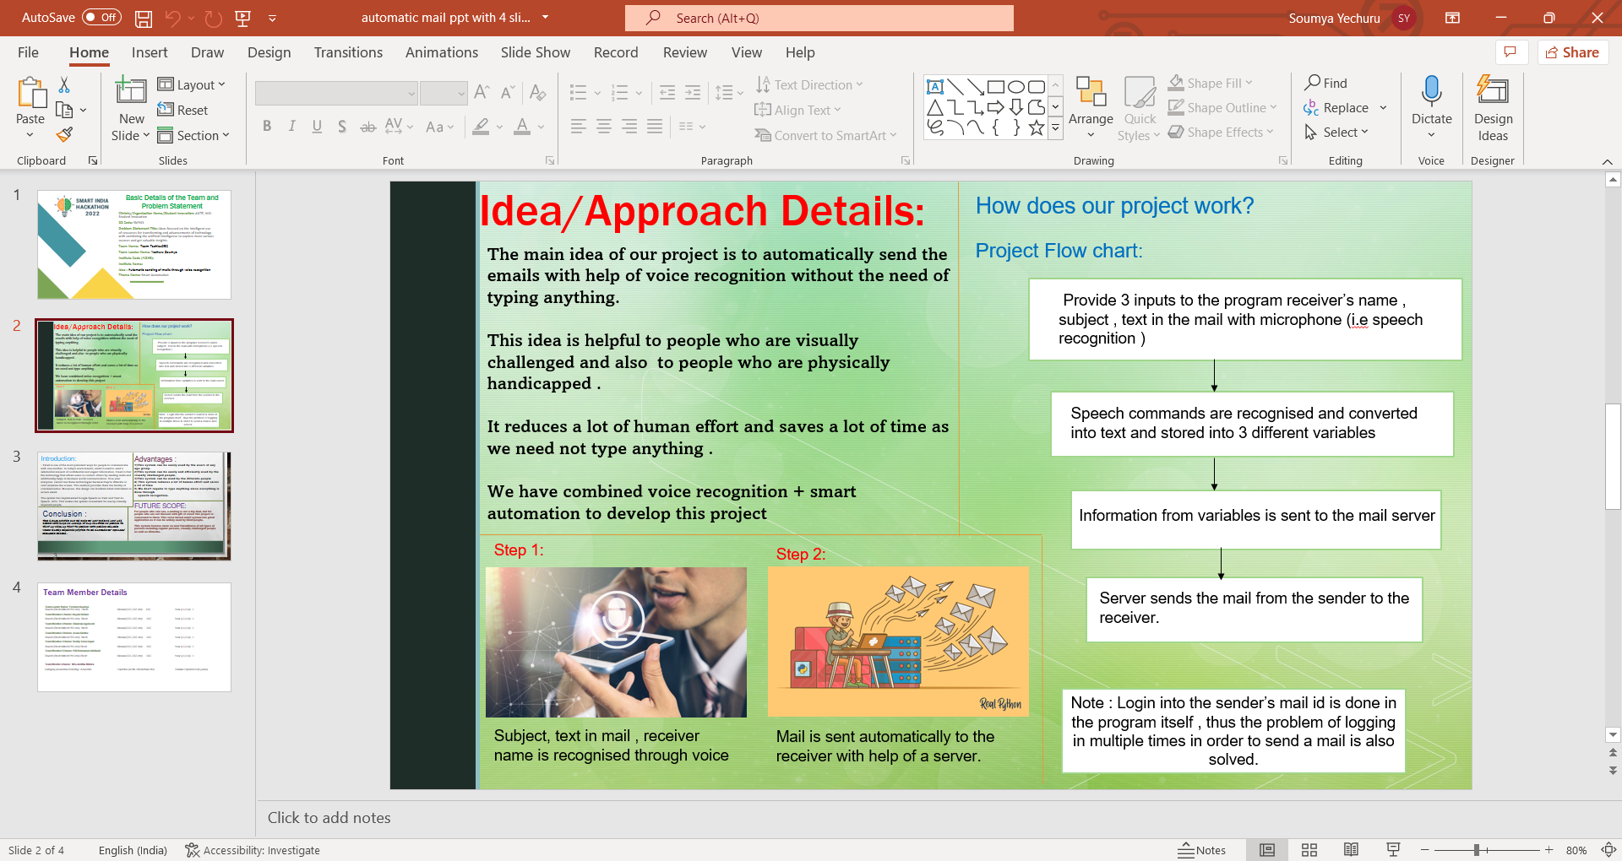

1. **SOFTWARE & HARDWARE REQUIREMENTS**
   1. **SOFTWARE REQUIREMENTS**:

Tools Used:

• Python IDLE.

• Interpreters for scripts.

• Selenium Web driver in python.

• Google Speech-to-text and text-to-speech Converters.

• Pyttsx text to speech api in python.

**3.2 Hardware Requirements:**

• Windows Desktop

1. **SOFTWARE DESIGN**

**4.1 Design Phases of The Proposed System**

**A. Phase-1:**

The tasks that can be performed using the program developed will be prompted using the voice prompt. In background python module pyttsx3 is used for text to speech conversion.

User will be asked to provide input for the following tasks written below.

The input is expected in the form of speech by the user which will be converted to text by the Google speech application interface in python and accordingly tasks will be performed.

• Login to their Gmail account.

• Send e-mail through Gmail.

• Read e-mail through Gmail.

**B. Phase-2:**

In phase-2 of our program the user will give speech input to the system.

This speech input will be handled by speech_recognition module.It is a python library which is used to handle the voice requests and it converts speech into text.

Now after receiving input from the user speech to text converter will save the response in respective variables used in the script and based on their value it will further enter into respective modules.

**4.2 IMPLEMENTATION**

**4.2.1 SPEECH RECOGNITION IN PYTHON**

The improvement and accessibility alone in the field of speech recognition are worth considerable. It allows the physically and the elderly and visually challenged people to collaborate with state of the art products and services quickly and naturally no graphical user interface is needed.

If you want to use speech recognition or simply convert speech to text in your python it is very easy to use. Let’s see how:-

• Working of speech recognition.

• Packages available in PyPI.

• How to install and how to use speech recognition package using python library.

A handful of packages for speech recognition exist on PyPI. A few of them include:

• Google-cloud-speech

• Watson-developer-cloud

• Pocketsphinx

• Wit

• Apiai

• Speech Recognition

SpeechRecognition is a library that acts as a wrapper for many popular speech APIs and is thus very flexible to use. One of these is the Google Web Speech API which supports a default API key that is hard coded into the SpeechRecognition library.

The elasticity and easy to use features of the SpeechRecognition package in python make it a very good choice for developers who are working on any python project. It does not guarantee to support every feature that is wrapped with this API. You will have to dispense some time searching for the easily available options to find out if SpeechRecognition is going work in your particular case.

**4.2.2 REQUIRED INSTALLATIONS**

SpeechRecognition is the library which is compatible with Python 2.6, 2.7 and 3.3+, but it will require some additional installation steps for Python v2.0. For our project we have used Python v3.0+.

1.>shell-$ pip install SpeechRecognition.

2.>shell-$ pip install python3-pyaudio.

SpeechRecognition will work very good if you need to work with existing audio files. The pyaudio package comes in play when you need to capture microphone input.

The main class which is used in this package is Recognizer class. The use of recognizer instance is obviously to recognize the speech. Every instance of this class comes with various settings and functionality for recognizing speech from the speaker.



**4.2.3 Speech To Text Demonstration**

The Microphone class used in this python program will let the user use the default microphone of their system instead of using some audio files as a source.

If the system of the user doesn’t have the default microphone or in case they want to use some other microphone then they will need to specify which one to use by giving a device index. The list can be seen by calling list_microphone_names() which is static method of Microphone class.

* Every instance of Recognizer class has seven methods for recognizing speech from speaker source using various APIs:- • recognize_bing(): Used in “Microsoft Bing Speech” • recognize_google(): Used in “Google Web Speech API” • recognize_google_cloud():Used in “Google Cloud Speech” - requires installation of the google-cloud-speech package • recognize_ibm(): Used in “IBM Speech to Text” • recognize_sphinx():Used in CMU Sphinx - requires installing PocketSphinx Input can be captured from microphone using listen() method of Recognizer class.
* The first argument taken by this method is an audio source and it will keep on detecting the audio input until the silence is detected by it.
* The audio input is generally mixed with ambient noises which can be handled by using the in-built method of recognizer class adjust_for_ambient_noise().
  + 1. **Pyttsx**

Pyttsx is platform independent that is it is compatible with Windows, Linux, and MacOS speech library. This offers a great set of functionality and features.

The user can set their voice metadata that is information about the data such as gender male or female, pitch of the voice, age, name and language. It supports large set of voices.

So to install it in windows platform depending upon which version of python you are using.

For example if you are using python3 so you need to install pyttsx3.

>>>shell> pip install pyttsx3.



**4.2.5 SIMPLE MAIL TRANSFER PROTOCOL(SMTP)**

Email is rising because the one among the foremost valuable service in net nowadays.

Most of the web systems use SMTP as a technique to transmit mail from one client to different. SMTP may be a thrust set of rules and is employed to send the mail whereas POP (post workplace protocol) or IMAP (internet message access protocol) square measure accustomed retrieve those mails at the receiver’s aspect.

SMTP is Associated with the application layer protocol of OSI model of network.

The user who desires to launch the mail open a TCP (Transmission Control Protocol) connection to the SMTP server and then sends the mail to the other connection. The SMTP server is mostly on listening mode. No sooner the server listens for a TCP connection from any user, the SMTP procedure initiate a connection usually on port number 25. When the successful establishment of TCP connection has been done, the client can send the mail.

The two processes that is sender process and the receiver process carry out a simple request response dialogue, outlined by the SMTP protocol within which the client process transmits the mail address of the mastermind and the recipient for a message. Once the server method accept these mail addresses, the consumer method broadcast the e-mail instant message. The message should include a message header and message text (“body”) formatted in accord with RFC 822.

The following example illustrates a message in the RFC 822 message format:

From: yashuchauhan@example.com

To: sauravmishra@example.com

Subject: An RFC 822 formatted message

This is a simple text body of the message.

The blank line separates the header and body of the message.

The SMTP model is of two types :-

**1.End-to- end method**

**2.Store-and- forward method**

The SMTP model chains both end-to-end no intermediate message transfer agents and store-and-forward mail delivery methods. The end-to-end method of SMTP is used between organization, and the store-and forward method is chosen for sending mails within organizations which have TCP/IP and SMTP-based networks.

**End-To-End**

In this method , a SMTP client will speak to the destination host’s SMTP server directly to transport the mail. It will keep the mail item from being transmitted until it has been successfully copied to the recipient’s SMTP.

**Store-and-Forward**

In this method a mail can be sent through a number of intermediary hosts, before reaching to the final destination.

A successful transmission from a hosts signify only that the mails has been sent to the next host, and then the mail will be sent to next host.

**4.2.6 SENDING EMAIL IN PYTHON USING SMTPLIB**

Automation of sending mails using Python can be done by using the smtplib module of Python. Smtplib contains the class SMTP which is useful to connect with mail servers and can be used to send mails. It defines a SMTP client session object which is used to send mail to any internet connected machine that depends on SMTP format.

SMTP is normally used to connect to a mail server and transmit the messages.

The mail server host name and port can be passed to the constructor, or you can use connect() explicitly.

Once connected, just call sendmail() with the envelope arguements and body of the message.

The message text should be a completely created RFC 822-compliant message, since smtplib does not alter the contents of headers.

We have to add header and sender mail and receiver mail by ourselves.

S1 = smtplib.SMTP( h , p , l)

Where h=host name, p=port number,l=localhost name

Host – The argument is used to represent the host which provides you SMTP server. We can specify IP address of the host or a domain name like gmail.com or outlook.com. It is not a compulsory argument.

Port - If the host name is provided then we have to give a port number where SMTP server will listen the requests, normally this port number is 25.

Local hostname - If your SMTP server is running on your local machine, then you can give just localhost in this argument.

An SMTP object has a method called sendmail, which is usually used to send the mails. It takes following parameters -

The sender - Email-Id of sender.

The receivers - Email-Ids of receivers.

The message - A message arranged like RFC822



**4.3 FLOW CHART**

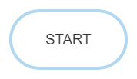

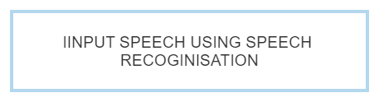

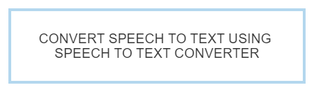

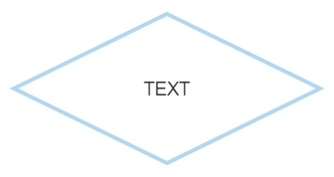

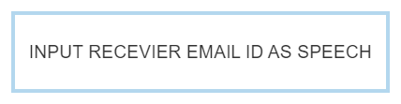

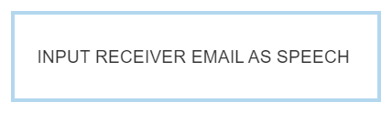

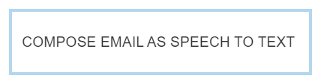

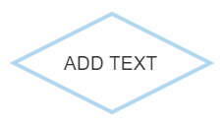





**4.4 USE CASE DIAGRAM**

A use case is a description of how project users will complete task . A use case is a description of a series of interactions between a user and a project that does not include the user interface .A use case is made up of two parts, the steps a user will take to complete a certain project assignment; and how the project should react to a user's activities. A use case begins with a user's aim and ends with the achievement of that goal. A use case diagram depicts the relationship between actor and use case graphically. A user or another system that will interact with the system you're modeling is represented by an actor in a use case



GMAIL





PYTHON

USER

* 1. **CLASS DIAGRAM**

Class diagram is a static diagram. Class diagram describes the attributes and operations of a class and also the constraints imposed on the system. class diagram is to model the static view of an application. Here we have the system ,user, python programing language ,mail.

PYTHON PROGRAMMING LANGUAGE

-PYTHON IDE

+ Selenium Web driver in python. +Google Speech-to-text and text-to-speech Converters.

+Pyttsx text to speech api in python

MAIL

-EMAIL ID

+SEND EMAIL

+RECEVE EMAIL

SYSTEM

MAC ADDRESS

IP ADDRESS

+PYHTON

+MIC

+OS

USER

-USER ID

+SEND EMAIL

1. **CODING**

**5.1 SAMPLE CODE**

import smtplib

import speech_recognition as sr

import pyttsx3

from email.message import EmailMessage

listener = sr.Recognizer()

engine = pyttsx3.init()

def talk(text):

engine.say(text)

engine.runAndWait()

def get_info():

try:

with sr.Microphone() as source:

print('listening...')

voice = listener.listen(source)

info = listener.recognize_google(voice)

print(info)

return info.lower()

except:

pass

def send_email(receiver, subject, message):

server = smtplib.SMTP('smtp.gmail.com', 587)

server.starttls()

# Make sure to give app access in your Google account

server.login('Sender_Email', 'Sender_Email_password')

email = EmailMessage()

email['From'] = 'Sender_Email'

email['To'] = receiver

email['Subject'] = subject

email.set_content(message)

server.send_message(email)

email_list = {

'hari': “208r1a0591@gmail,com”

'maheer': ''’208r1a05b3@cmrec.ac.in’

'ARUN': '’208r1a0585@cmrec.ac.in’

'soumya': ”208r1a05c0@cmrec.ac.in”

}

def get_email_info():

talk('To Whom you want to send email')

name = get_info()

receiver = email_list[name]

print(receiver)

talk('What is the subject of your email?')

subject = get_info()

talk('Tell me the text in your email')

message = get_info()

send_email(receiver, subject, message)

talk('Hey , Your email is sent')

talk('Do you want to send more email?')

send_more = get_info()

if 'yes' in send_more:

get_email_info()

get_email_info()

1. **OUTPUT SCREENS**

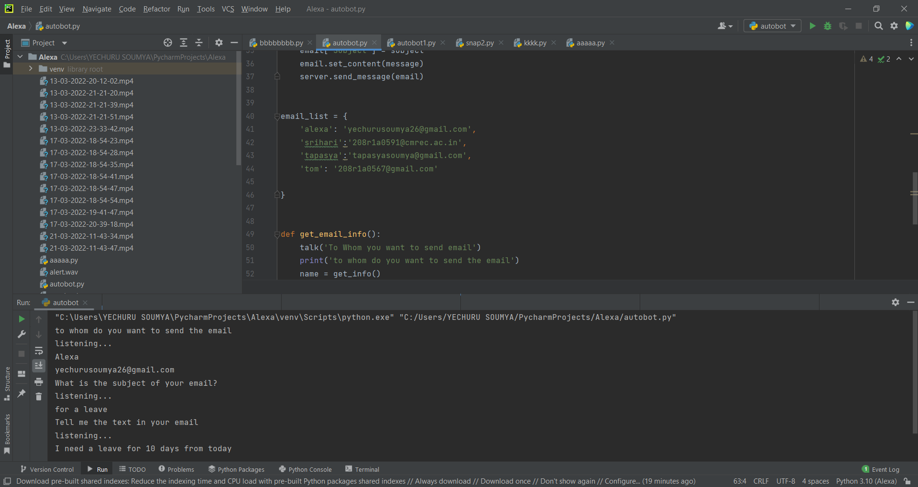

1. **CONCLUSION**

In this study, we suggest a solution that will assist visually challenged people in easily accessing email services.This approach will assist blind persons in overcoming some of the challenges they previously had in accessing emails.We've done away with keyboard shortcuts in favour of screen readers, which will help reduce the cognitive strain of knowing keyboard shortcuts.Furthermore, any naive user who is unfamiliar with the location of keys on the keyboard need not be concerned, as keyboard usage is no longer required.To obtain the services supplied, the user simply needs to follow the directions provided by the IVR and make appropriate mouse clicks.Aside from that, the user may be required to provide information via voice inputs when required. It has been estimated that India is home to over 70% of the world's total blind population.This paper describes the voice mail architecture used by blind individuals to simply and efficiently use E-mail and multimedia functionalities of the operating system.This architecture will help lessen the cognitive load that blind people must bear when remembering and typing characters on a keyboard.It also aids the crippled and illiterate.

This e-mail system can be used by any user of any age group with ease of access. It has highlight of speech to content just as content to speech with discourse reader which makes planned framework to be taken care of by outwardly hindered individual too. Now the visually impaired people can send and receive mails with a lot of ease only through voice commands without making any use of a keyboard or any mouse. It has helped eradicate the difficulties that the blind people face and made them more the normal individuals.

It has wiped out the idea of utilizing console easy routes alongside screen readers which will help decreasing the intellectual heap of recollecting console alternate ways. Also any non-sophisticated user who does not know the position of keys on the keyboard need not bother as keyboard usage is eliminated. Instructions given by the IVR accordingly to get the respective services offered.

1. **FUTURE SCOPE**

E-mailing isn't a significant difficulty for those who can see, but it's a major concern for those who don't have the gift of sight because it intersects with so many job obligations.This voice-based email system is useful for blind individuals since it allows them to comprehend where they are.For example, whenever the cursor travels over the Register icon on the page, it will sound like "Register Button."There are a plethora of screen readers to choose from.People, on the other hand, have to recall mouse clicks.Rather, because the mouse cursor will read out where he or she is, this project will alleviate the difficulty.This method places a greater emphasis on user friendliness for all types of users, including typical people, visually impaired people, and illiterates. It can be expanded to read certain emails.Marking emails as read or unread, as well as all of the other features that comes standard with the Gmail service. It is a observation that about 70% of total blind population across the world is present in INDIA. This depict the voice message engineering utilized by daze individuals to get to E-mail and multimedia elements of working framework effectively and efficiently. Separated from this the uneducated, crippled and daze individuals will too be able to send sends in their local dialects. This design will likewise decrease intellectual burden taken by blinds to recall and type characters utilizing console. Advances in technology will allow consumers and business to implement speech recognition systems at a relatively low cost and efficiently. Apart from this the system can be enhanced to help the illiterate people by making speech recognition possible in their native languages.

**8.1 ADVANTAGES**

* The disabilities of visually impaired folks are thrashed.
* This method makes the disabled folks desire a standard user.
* Completely voice based, wiped out the use of keyboard and mouse.
* Efficient and robust
* This design also scales back psychological feature load taken by blind to recollect and kind characters mistreatment keyboard.
* User friendly
* This system can be easily used by the users of any age group.
* This system can be easily and efficiently used by the visually challenged people.
* This system can be used by the illiterate people
* This system reduces a lot of human effort and saves a lot of time
* We don’t require to type anything since everything is done through
* speech recognition.

1. **REFERENCES**

[1] Jagtap Nilesh, Pawan Alai, Chavhan Swapnil and Bendre M.R.. “Voice Based System in Desktop and Mobile Devices for Blind People”. In International Journal of Emerging Technology and Advanced Engineering (IJETAE), 2014 on Pages 404-407 (Volume 4, issue 2).

[2] Ummuhanysifa U.,Nizar Banu P K , “Voice Based Search Engine and Web page Reader”. In Internationa Journal of Computational Engineering Research (IJCER). Pages 1-5.

[3] The Radicati website. [Online]. Available: http://www.radicati.com/wp/wp-content/uploads/2014/01/EmailStatistics-Report-2014-2018-Executive-Summary.pdf.

[4] Geeks for geeks - https://www.geeksforgeeks.org/project-idea-voice-based-email-visually-challenged/

[5] K. Jayachandran and P. Anbumani “Voice Based Email for Blind People” in International Journal of Advance Research, Ideas and Innovations in Technology(IJARIIT),2017 on Pages 1065-1071

[6] Pranjal Ingle, Harshada Kanade and Arti Lanke “ Voice based e-mail system for blinds” in International Journal of Research Studies in Computer Science and Engineering(IJRSCSE), 2016 on Pages 25-30 (Volume 3, issue 1)

[7] G. Broll, S. Keck, P. Holleis and A. Butz, “Improving the Accessibility of NFC/RFID-based Mobile Interaction through Learnability and Guidance”, International Conference on Human-Computer Interaction with Mobile devices and services, vol. 11, (2009).